|  |
| --- |
| Functional Design Document |
| CHG212943 |
| CHG OM - IM: Stock Receive - Ability to allocate products to TM |
| Markets: All |
| Release: RLS000700 (Feb’22) |



Contents

A. Document approval 3

B. Revision history 3

1. Business Process Overview 4

1.1 Process Overview 4

1.2 Impact Matrix 4

2. Description of the functional change 5

2.1 Changes in Siebel Sales 5

2.2 English Captions 5

2.3 Changes in the ETL 5

2.3.1 Initial Loads/Massive Data updates 6

2.3.2 Performance test/Indexes creation 6

2.4 Changes in OBI 6

2.5 Data Dictionary 7

2.6 Changes in Data Interfaces 7

2.6.1 Inbound 7

2.6.2 Outbound 8

2.6.3. Initial Loads 8

2.6.4 Performance test / Indexes creation 8

2.7 Changes in Batch Processes / Aggregations / DRP 8

2.8 Use Case 8

# Document approval

|  |  |  |
| --- | --- | --- |
| Role | Name | Function |
| **Market Sponsor** |  |  |
| **DBU Approver** | Nikita Ryzhkovich | Digital Customer Experience |
| **BTS expert** | Elena Voronina | BTS TME Manager |
| **ODC expert** | David Gallego | ODC Sales |
| **ODC expert** | Fran / Migual Lopez | ODC Data |
| **GTC expert** | Jose Carlos Martin | TME Tech Arch Mgr |

This is to confirm that we have reviewed the functional specifications for the proposed solution. We agree with its contents and understand that the technical specifications will be designed based on this approved document.

# Revision history

|  |  |  |  |  |
| --- | --- | --- | --- | --- |
| Revision | Section(s) | Description | Editor | Date |
| 1.0 | - | Draft | J.Andreyeva | 10.02.2021 |
| 1.1 | 1.1 | Business Process updated | J.Andreyeva | 20.07.2021 |
| 1.2 |  |  |  |  |
| 2.0 |  |  |  |  |
| 2.1 |  |  |  |  |
|  |  |  |  |  |
|  |  |  |  |  |
|  |  |  |  |  |

# Business Process Overview

## Process Overview

Stock receive is part of inventory management process. It’s initiated from Back office to allocate product stock for trade marketers.

There are several ways in the current solution that allows for back office to allocate products to the trade marketer either by creation of the service orders or creation of inventory transactions.

However, current processes don’t allow for TMs to inform the physical quantities received. This enhancement is being addressed by this change request.

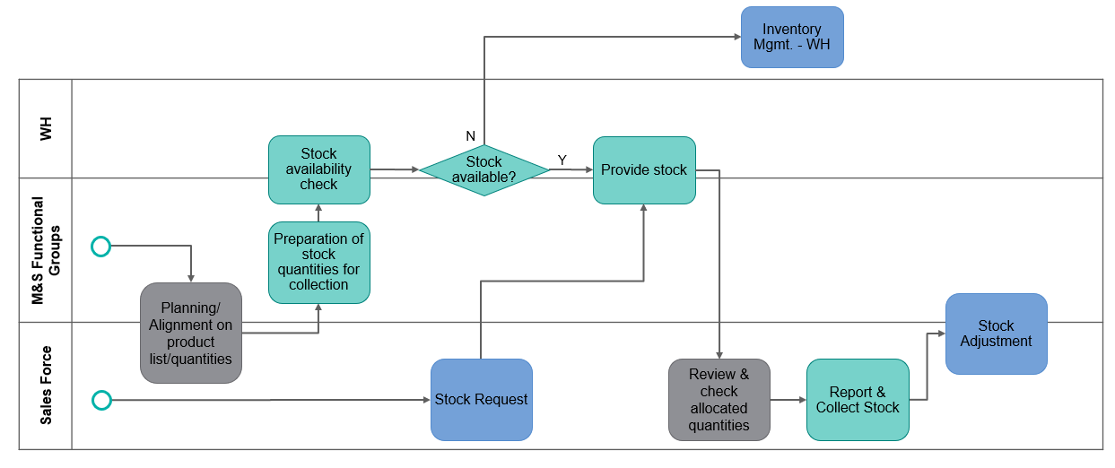

## Impact Matrix

|  |  |
| --- | --- |
| GRM Functionality | Order |
| Impact Current Functionality? | Yes |
| Markets Affected | All |
| Applications Affected | Sales / Data / BI |
| Risk of Implementing the change | Medium |

# Description of the functional change

## Changes in Siebel Sales

[Backend]

Stock allocation process starts with Back office creation of service order of type ‘Stock Receive’ and selection of TMs inventory location (Virtual Account of type ‘Employee’ for whom product allocation is planned.

* New service order type ‘Stock Receive’ (order category = ‘Service Order’ created as part of the CHG212925) should be created and the flow of the order should be configured to be able to support the corresponding process on mobile

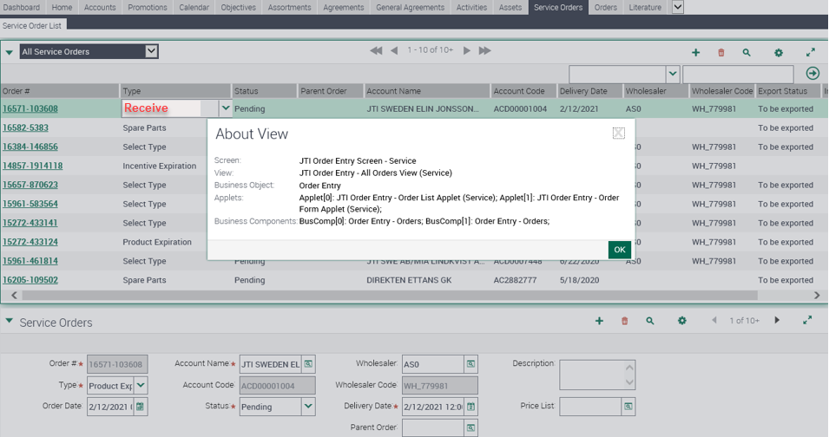

Back office adds products in it in back end and submit it (status of service order changes to ‘Pending’).

Back office shouldn’t be able to change Stock Receive if it was set to ‘Pending’

@ODC: Validation o Read only – to be decided as part of the dev analysis. To evaluate if other status should be created to support this requirement

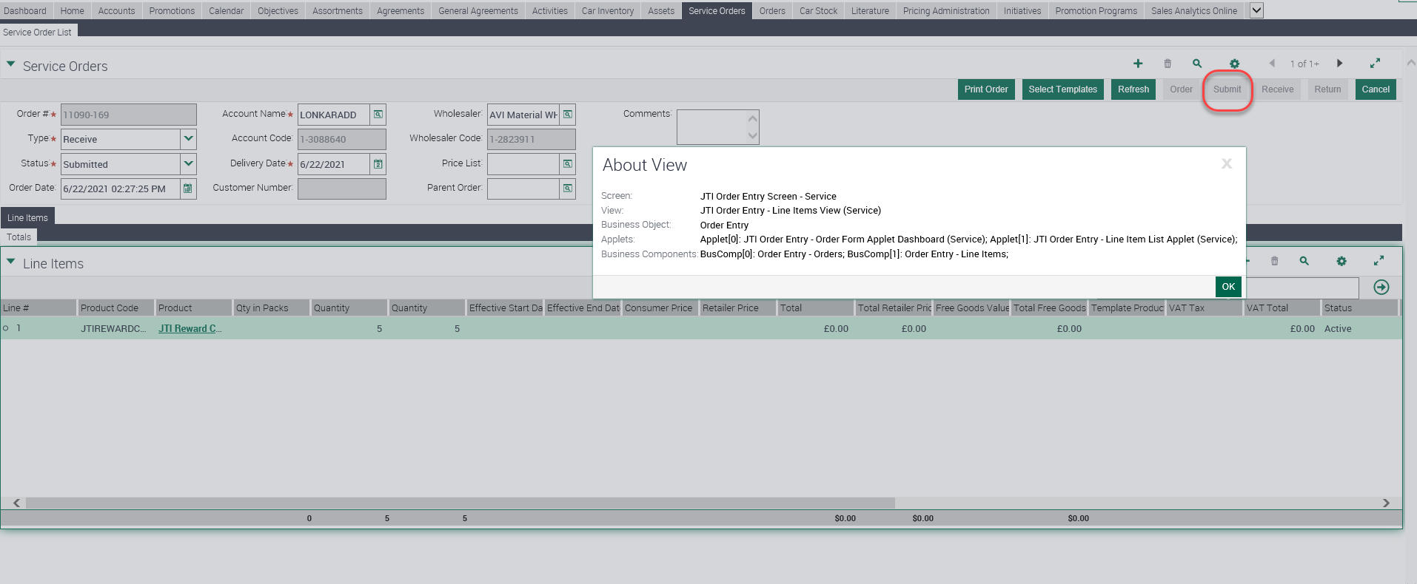

[Mobile]

Trade Marketer synchronizes mobile app. Once synchronized, the service order is available on the TMEC mobile application as new stock movement of type “Receive’ and has a status “Pending”.

This Stock Movement needs to be revised by trade marketer on the mobile app at this stage

Trade Marketer should inform the physical product stock quantities being collected. It’s possible either to confirm the entire receive or drill down to the record and update receive quantities.

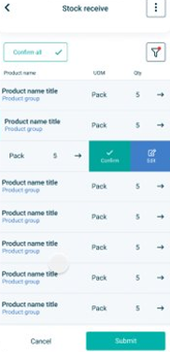 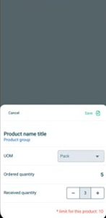

Once completed, stock receive is submitted (status should be changed to “Submitted” if everything is correct) or rejected if not. TM is not able to update the request anymore.

[Backend] – To be included in User story dedicated to mobile app development.

@ODC: to align internally

After synchronization, in Siebel Sales the status of the service order is being updated to ‘Received’, ‘Received Qty’ and ‘Received Date’ fields are updated with the quantities confirmed by trade marketer and the day when it has happened

Trade Marketer Inventory would be updated accordingly.

After synchronization the service order should be reflected in Sales and corresponding inventory transactions with type ‘Allocate’ being created. Transactions are being referenced to the service order initiated by the back office.

|  |  |  |  |  |  |  |  |
| --- | --- | --- | --- | --- | --- | --- | --- |
| Order Type | Order | Impact on TM's Inventory | Source Availability | Source Inventory Location | Destination Availability | Destination Inventory Location | Comments |
| Stock Receive | Service | Yes | On Hand | Virtual Inventory Location | On Hand | TM Inventory Location |  |

The summary of the statuses that service order of type ‘Stock Receive’ could have:

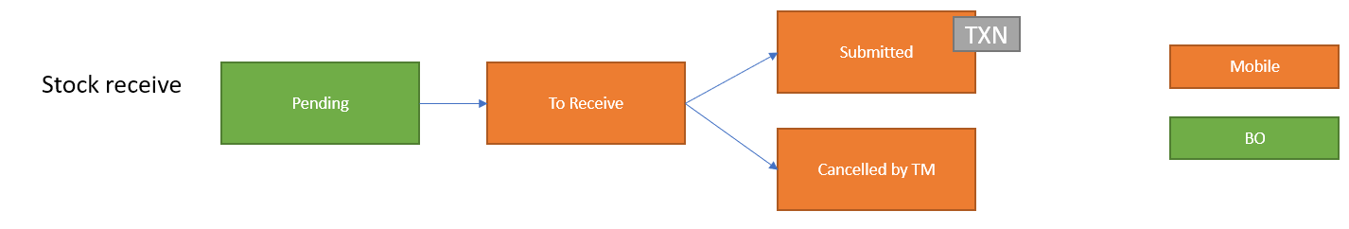

## English Captions

|  |  |  |  |  |
| --- | --- | --- | --- | --- |
| Type | Format | Caption ENU | Language | Caption LOCAL |
| Button |  | Submit | ESN | Enviar |
| Button |  | Submit | CSY | TBC |

|  |  |  |  |  |  |
| --- | --- | --- | --- | --- | --- |
| Type | Display | LIC | Parent LIC | Language | Organization |
| JTI_SUBTYPE_TYPE | Recibida de stock | Stock Receive |  | ESN | Spain |
| LOV | Pendiente | Pending |  | ESN |  |
| LOV | Rechazado | Rejected |  | ESN |  |
| LOV | Enviado | Submitted |  | ESN |  |
| LOV | Cancelado | Cancelled |  | ESN |  |
| LOV | Recibida | Received |  | ESN |  |
| JTI_SUBTYPE_TYPE | TBC | Stock Receive |  | CSY | Czech |
| LOV | TBC | Pending |  | CSY |  |
| LOV | TBC | Rejected |  | CSY |  |
| LOV | TBC | Submitted |  | CSY |  |
| LOV | TBC | Cancelled |  | CSY |  |
| LOV | TBC | Received |  | CSY |  |

## Changes in the ETL

No applicable

|  |  |  |  |  |  |
| --- | --- | --- | --- | --- | --- |
|  | OLTP Source | | ETL | OLAP Target | |
| # | **Entity** | **Attribute** | **Transformation** | **Entity** | **Attribute** |
|  |  |  |  |  |  |

## Initial Loads/Massive Data updates

Not applicable

|  |  |  |  |  |  |
| --- | --- | --- | --- | --- | --- |
| Data Update | | | | | |
| # | **Entity** | **Markets** | **Periods** | **Urgent (ODC)** | **Remarks** |
|  |  |  |  |  |  |

## Performance test/Indexes creation

Not applicable

## Changes in OBI

New dimensions should be added to OBIEE.

## Data Dictionary

Not applicable

## Changes in Data Interfaces

## Inbound

Not applicable

|  |  |  |  |  |  |
| --- | --- | --- | --- | --- | --- |
| N/A | | | | | |
| **#** | **Entity** | **Field Name** | **Contents** | **Data type/format** | **Transformation** |
|  |  |  |  |  |  |

## Outbound

Sales Order Outbound interface rule for Spain market should be enhanced: service order of type “Stock Receive” needs to be included.

|  |  |  |  |  |  |
| --- | --- | --- | --- | --- | --- |
| OLTP Sales Order Outbound – SO | | | | | |
| # | **Entity** | **Field Name** | **Contents** | **Data type/format** | **Transformation** |

## 

## Initial Loads

Not applicable

## Performance test / Indexes creation

Not applicable

## Changes in Batch Processes / Aggregations / DRP

No applicable

## Use Case

|  |  |  |
| --- | --- | --- |
| Role  *Trade Marketer, ASM, Local Admin…* | Application  *Sales, Analytics, ETL, Batch, Interface* | Step  *Description of the step and its expected output* |
| Back office: PO, ASM, Local Admin, TM | Siebel Sales/OBIEE/TMEC mobile | Navigate to view JTI Order Entity – All Orders View (Service)  Create service order with type “Receive”  Specify inventory location  Add products  Press submit button  Service Order status changes to submitted  Do synchronization  Check in TMEC mobile new stock receive with type “Receive” and status “Pending”  Revise receive request  Change status to submitted/Rejected  Check that the appropriate stock mgmt. transaction has been generated in OLTP  Wait for Nightly ETL. Validate that the field is transferred to OBIEE |